Smile Squad communication toolkit for schools
Social media channels, newsletter or school portal content
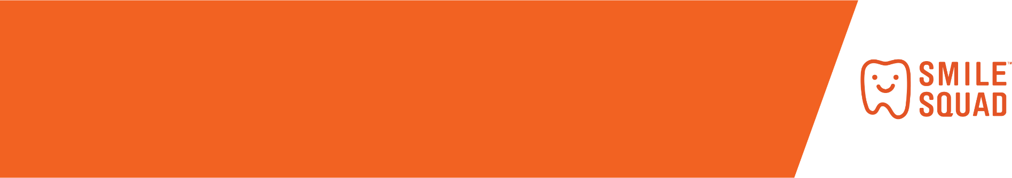

Copy and paste this content into your school’s social media channels, newsletter or use it for your school portal (e.g. Compass). You can update it as needed to suit the needs of your school. We’ve made some suggestions about when to share these messages with your school community.
If you are posting on social media, don’t forget to:
Tag us
Facebook @dentalhealthvic
Twitter @vicdental
Instagram @dhsv
Use the Smile Squad hashtags
#smilesquad #freedental #vicdental #healthysmiles

General messages about the program
When to share | Content | Recommended image
After electronic consent form link has been shared / paper consent forms sent home | Don’t forget your Smile Squad consent form!  The friendly Smile Squad dental team is visiting our school to do free dental checks.  Don’t forget to complete your consent form. Until then, eat well, drink well and clean well for a healthy smile!  To find out more about the Smile Squad visit www.smilesquad.vic.gov.au | Smile Squad examination van.jpg  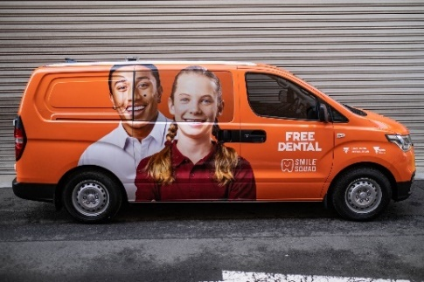
When dental packs are sent home with students | Get brushing with the Smile Squad dental pack!  The friendly Smile Squad dental team will visit our school soon to do free dental checks.  In preparation for the visit, every student has been provided with a Smile Squad dental pack.  Make the most of your pack and get brushing now! Don’t forget to complete your consent forms too.  To find out more about the Smile Squad visit www.smilesquad.vic.gov.au | 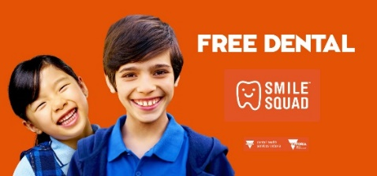  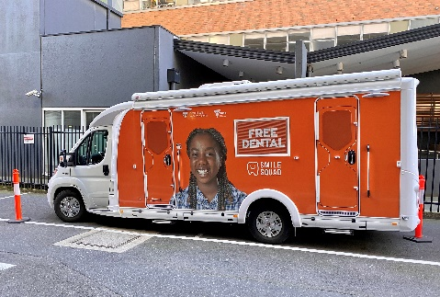  Smile Squad social tile.jpg  Smile Squad treatment van [1] or [2].jpg

Eat well, drink well, clean well with the Smile Squad
To keep families informed about the Smile Squad’s visit to your school, we’ve prepared some information about the program that you can share to help make the journey fun, as well as informative. This content includes information on how to achieve and maintain good oral health for life.
We’ve made some suggestions about when to share these messages with your school community.
For use by | When to share | Content | Image to use
Primary schools | At school’s discretion | Eat well to look after your teeth.  Offer healthy snacks between main meals such as fruit and vegetables that are low in sugar.  Eating sweet or sugary snacks too often can lead to tooth decay. | Eat well_primary schools [1].jpg  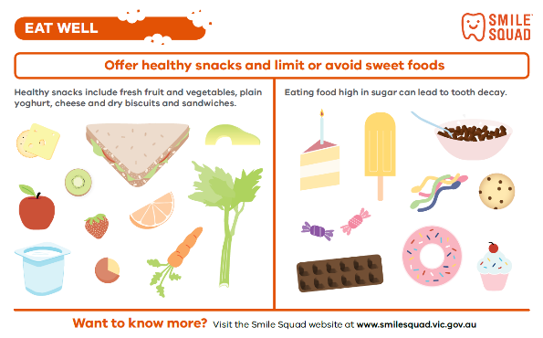
Primary schools | At school’s discretion | How much sugar is too much?  Experts recommend no more than 6 to 7 teaspoons of added sugar for adults and even less for children.  A few simple healthier choices can help you cut down the amount of added sugar your family eats. | Eat well_primary schools [2].jpg  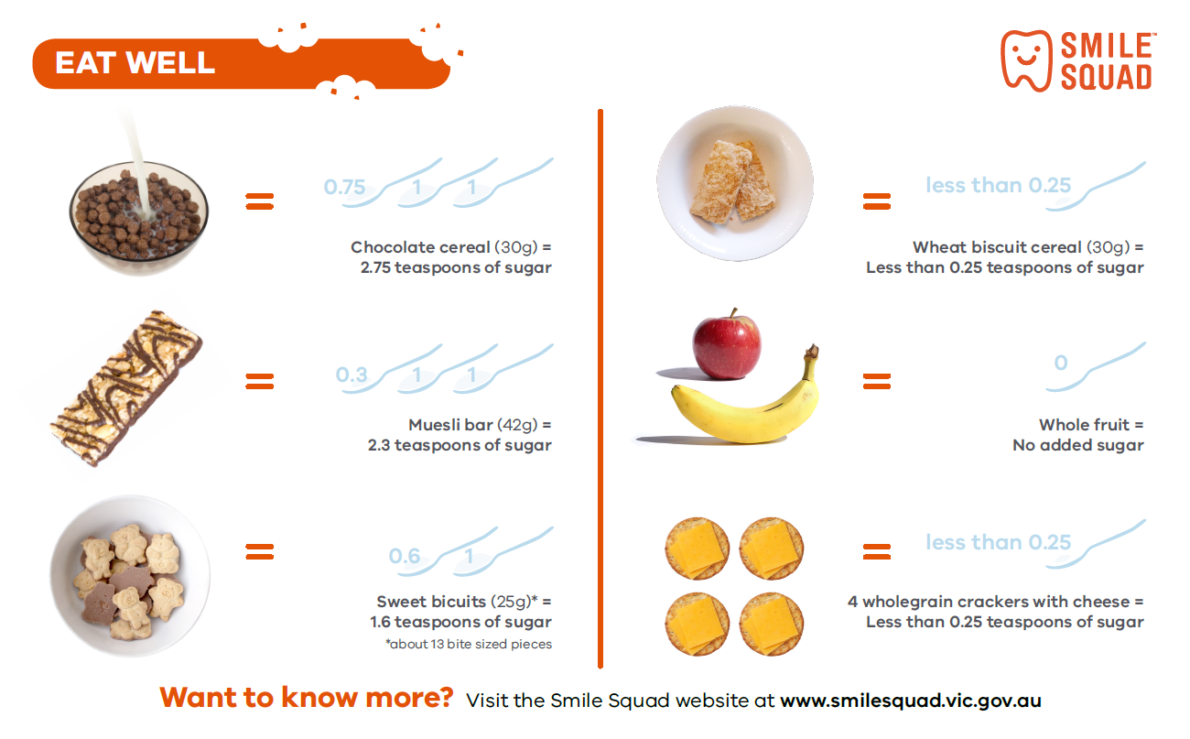
Primary schools  Secondary schools | At school’s discretion | How much sugar should you have a day?  Experts recommend no more than 6 to 7 teaspoons of added sugar for adults (and even less for children).  But keeping an eye out for sugar in foods can be a little tricky. The next time you shop, have a look at the ‘Sugars’ line on the food label.  It can be easier to picture the amount of sugar in teaspoons. Work this out by dividing the amount by 4.  So, 28 grams divided by 4 = 7 teaspoons of sugar. Just be mindful about using the printed serving size. This may not be the same as your own!  *This image must be used alongside the supporting text to make sense. | Eat well_secondary schools.jpg  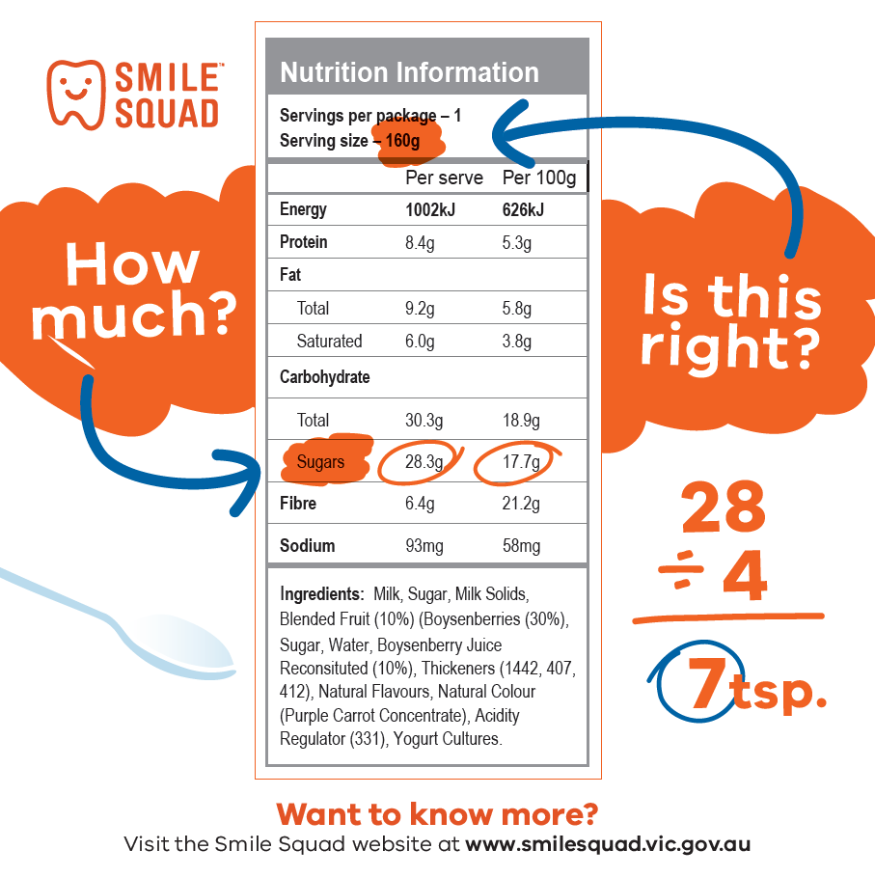
Primary schools  Secondary schools | At school’s discretion | Need some inspiration to eat well?  Treat your tastebuds with some delicious meals and snacks from these great recipe collections.  https://www.betterhealth.vic.gov.au/healthyliving/recipes  https://livelighter.com.au/Recipe  https://healthylunchbox.com.au/recipes/  By the way they also happen to be healthy (but you don’t have to tell the kids that). | Screen grabs from relevant websites  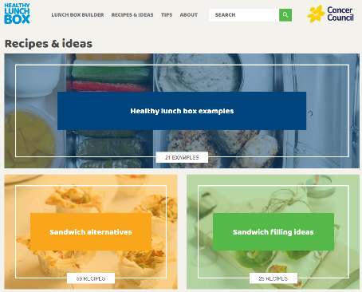  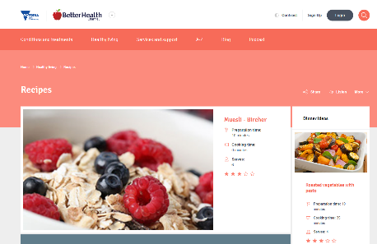
Primary schools | At school’s discretion | Healthy drinks are important for healthy teeth.  Drinking tap water is the best way to quench your thirst. Even better, it’s free and doesn’t come with all the sugar found in fruit juice drinks, soft drinks, slurpees, sports drinks and flavoured mineral waters.  Water is great – it’s free, refreshing and there’s no sugar.  Most of Victoria’s tap water supply has fluoride in it. Fluoride protects teeth from decay.  Find out if your drinking water is fluoridated using this handy online tool: https://bit.ly/2lI0QWG | Drink well_primary schools.jpg  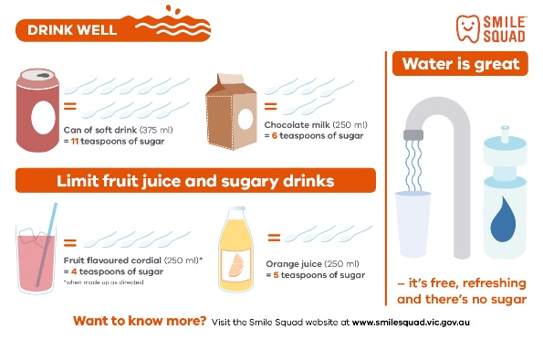
Secondary schools | At school’s discretion | #Rethinksugarydrink  Sugary drinks are just not worth losing your teeth over. #Rethinksugarydrink and go for water instead – https://bit.ly/2ShKG1N | Drink well_secondary schools.jpg  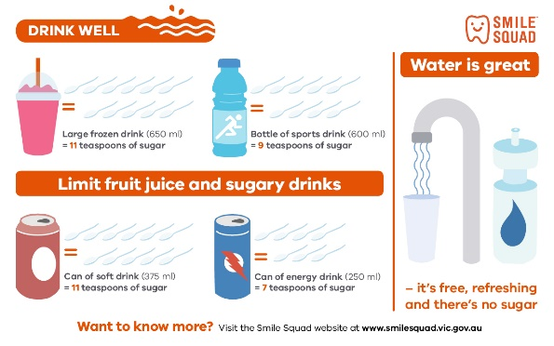
Primary schools  Secondary schools | After Smile Squad dental packs are given to students | 2x2 is all it takes!  Brush twice a day for two minutes for a healthy smile.  Strong, healthy teeth help you chew foods and speak clearly.  Get brushing with your Smile Squad dental pack! | Clean well_how to brush your teeth.jpg  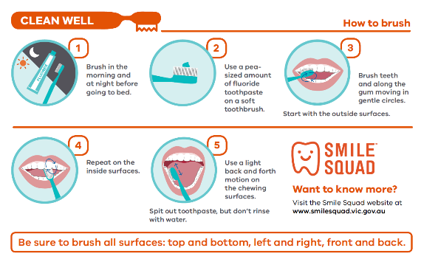

Smile Squad website badge
Are you proud to be a Smile Squad school? Download our Smile Squad badge and add it to your website.
