Oral health newsletter articles:

For early years
Contents
How to use these articles 3

ABOUT TEETH
Teaching good dental health practices at our service 4
Why it’s important to look after baby teeth 4
7 signs of teething 5
When do adult teeth come through? 6
Tooth decay – and how to avoid it 7
Are your child’s gums tender and swollen? 7
What is baby bottle tooth decay? 8

DRINK WELL
Introducing Drink well key messages at our service 9
How to choose healthy drinks for strong teeth 9
How to switch from a bottle to a cup 10
Why drinking water is so important 11
Drink tap water: a repair kit for your teeth! 11
How much water should children drink? 12
Tips for tapping into water 12
Are DIET soft drinks okay for my child’s teeth? 13
Is fruit juice as healthy as it seems? 13
Top 4 reasons to avoid sweet drinks 14
How to switch from sugary drinks to tap water 14
Which milk is best for kids? 15
How much milk should my child drink? 16

EAT WELL
Introducing Eat well key messages at our service 17
How to choose foods for strong and healthy teeth 17
Top tips to get your child to eat more fruit and veg! 18
Which ‘healthy’ foods are actually bad for your teeth? 18
Why our service supports healthy fundraising 19

CLEAN WELL
Introducing Clean well key messages at our service 20
An easy guide to cleaning well 20
How to brush your child’s teeth 21
Taking the fuss out of the brush! 21
What toothpaste should I use for my child? 22
Does my child need to floss? 23

STAY WELL
When should my child have their first dental check-up? 24
Did you know children can visit the dentist for free? 25
How to find your local dental service 25
Is your child a thumb, finger or dummy sucker? 26
Teeth and sport – prevention is the key! 27

Appendix A
About Teeth 28
Appendix B
Drink well 28
Appendix C
Eat well 29
Appendix D
Clean well 31
Appendix E
Stay well 32

How to use these articles

This series of articles is designed to share in your regular communications with families, for example, newsletters, website, emails, handouts etc. The articles promote key oral health messages for newborns to pre-schoolers and beyond: Drink well, Eat well, Clean well and Stay well.

TARGET GROUPS
Some articles target particular age groups, while others are appropriate for all ages – we have indicated the intended audience above each article.

IMAGES
Your newsletters could include photos of children (with relevant permissions), who are doing activities relating to the Drink well, Eat well, Clean well and Stay well messages. We know families love to recognise their children in newsletters, and this will also make the information more meaningful for them.

In addition, images and graphics are included in the Appendix, which are free for your use.

ACKNOWLEDGEMENT
You are free to use any of the articles in this resource as they appear, however we ask that you acknowledge Dental Health Services Victoria as the source of this information. We have included this reference at the foot of each article. You may also choose to use the information to develop your own articles, if you prefer.

We would like to thank Northern District Health Service for their contribution to these articles.

About teeth

<Suitable for 0 – 5 year olds>

Teaching good dental health practices at our service
5 easy ways your child – and you – can take good care of their teeth.
There’s no doubt early childhood is a crucial time for growing healthy minds and establishing healthy habits. While care of the teeth often begins at home, we can play a significant role in supporting dental health at <insert service name>.

We are committed to helping children – and families – learn about the steps to good dental health and to build good dental practises into our daily program. This includes sharing the importance of:
- drinking tap water;
- eating healthy foods;
- limiting sweet foods and drinks;
- brushing our teeth twice a day; and
- visiting the dentist.

To find your closest public dental clinic visit the Dental Health Services Victoria website.
* This information is courtesy of Dental Health Services Victoria.

<Suitable for 0 – 12 year olds>

Why it’s important to look after baby teeth
Here’s what you need to know about caring for baby teeth.

Did you know your child can have their baby teeth until they are 12-years-old? Baby teeth are important for many reasons and need to be taken care of until adult (or permanent) teeth replace them. Here’s why.

Baby teeth – also called primary or deciduous teeth – play an important role in helping your child:
- learn to speak;
- keep space in their mouth for adult teeth to grow;
- shape and develop their face; and
- eat a wide variety of foods.

But, that’s not the only reason why it’s we must look after them. Tooth decay in baby teeth can mean your child is more likely to get tooth decay in their permanent teeth. And, remember, these permanent teeth need to last 70 to 80 years!

When baby teeth grow
Your baby’s first teeth will usually come through when they are between six and nine months old. Most children will have 20 baby teeth, including 10 in the upper jaw and 10 in the lower jaw by three years of age.

How to start cleaning baby teeth and gums
You can start caring for your baby's gums well before the first tooth appears. In fact, oral health care for newborns doesn’t involve a toothbrush and toothpaste. Instead, follow these three easy steps:

STEP 1 > Get a soft, wet face washer or piece of gauze.
STEP 2 > A couple of times a day gently wipe down your baby’s gums.
STEP 3 > As soon as teeth arrive, clean them twice a day, especially in the morning and before bedtime.

This helps wash bacteria away and prevent it from clinging to your baby’s gums. Bacteria can leave behind a sticky plaque that can damage infant teeth as they come through.

What about toothpaste?
Start cleaning your child’s teeth as soon as they appear either with a soft wet cloth or a small soft toothbrush and water. At the beginning, you do not need toothpaste. Once your child is 18 months, use a pea-sized amount of low fluoride toothpaste. Remember to teach children to clean morning and night as part of your family’s everyday routine. Encourage your child to spit out the toothpaste, but don’t rinse their mouth.

Supporting brushing
As young children do not have the fine motor skills needed to reach all of their teeth and to brush effectively, you should help brush your child’s teeth until they are eight years old. A good guide for knowing they are ready is when they are able to tie their own shoelaces.

Signs of tooth decay
Baby teeth are more at risk of decay than adult teeth. This is because the enamel (outer layer) is thinner and softer.

Stay on the lookout for any signs of tooth decay when brushing your child’s teeth – although the early stages of tooth decay can be hard to spot. If you think your child has early signs, such as white or brown spots on both the front and back teeth, or if you’re not sure, it’s important to have a dental check.

Remember, tooth decay can be painful, and may make it uncomfortable for your child to chew on food. It can also cause sleep problems, which can affect your child’s learning and development.

To find your closest public dental clinic visit the Dental Health Services Victoria website.
* This information is courtesy of Dental Health Services Victoria.

<Suitable for six-months – 3 year olds>
<Suitable image(s) can be located in Appendix A>

7 signs of teething
Know the signs and manage the symptoms of your teething tot.

Teething – or the natural process of teeth coming through the gums – usually begins around six months of age. However, a small number of babies get their first tooth earlier, and some will even be born with a tooth! Remember, all teeth should be cleaned once they come through.

From the age of six months to three years, children will get their full set of 20 baby teeth. Then, these baby teeth will begin to fall out at around age six and continue until your child is 12.

Signs of teething
Teething can cause some pain and discomfort to babies and toddlers. Signs your child is teething may include:
- restlessness during the day and sleeplessness at night;
- irritability;
- increased dribbling;
- red and swollen gums, which feel hard and pointed when pressed;
- rubbing gums together in a grinding motion;
- being fussy with food; and
- placing objects or fingers in the mouth.

A fever (or temperature above 37°C) is not associated with teething. If your child has a higher than normal temperature or diarrhoea, seek medical advice.

Managing teething symptoms
For temporary relief of teething symptoms, try giving your baby something to bite on such as a damp and cold face washer or a teething ring. Teething rings can be stored in the fridge to keep them cool, but never in the freezer.

Do not put anything sweet on the teething ring such as sugar, honey or jam. Babies over six months who have started eating solids may be given an unsweetened rusk.

Talk to your family dentist, doctor, maternal and child health nurse or pharmacist for more information about teething.

* This information is courtesy of Dental Health Services Victoria.

<Suitable for all ages>
<Suitable image(s) can be located in Appendix A>

When do adult teeth come through?
With 28 permanent teeth on the way, here’s what you can expect.
Like baby teeth, the timing for when adult teeth arrive differs for every child. However, they usually begin to appear when your child turns six. This means, generally, by age 13 they will have all 28 adult teeth.

Third molars, commonly called wisdom teeth, usually come through between the ages of 17 to 21. So, by the time your child has their 21st birthday, they will have 32 adult teeth, including 16 in the upper jaw and 16 in the lower jaw.

* This information is courtesy of Dental Health Services Victoria.

<Suitable for all ages>

Tooth decay – and how to avoid it
It’s the most common child health issue, but tooth decay can be prevented. Here’s how.

Did you know tooth decay is five times more common than asthma among young children?

In fact, half of all children experience tooth decay by the time they go to school. The worst part is, tooth decay can be painful, which can make it difficult to chew on food, and cause sleep problems, all which can affect your child’s learning and development.

Why tooth decay happens
Tooth decay begins when sugars from food and drinks are digested by bacteria in plaque (the clear, sticky coating that sticks to teeth) and forms acid.

This means, every time you eat or drink anything containing sugar or carbohydrates that can be broken down into sugar, acids can form which attack your teeth. This weakens your teeth as important minerals dissolve from the tooth enamel (the hard outer layer).

These acid attacks can last for up to an hour after eating or drinking before your saliva tries to repair the damage by putting minerals back in the enamel. If these ‘acid attacks’ happen a lot during the day, the tooth can become weak and, over time, create a hole – this is decay!

How to prevent tooth decay
The good news is, tooth decay is preventable. So, to stop decay in its tracks, try to:
- drink tap water instead of sugary drinks such as cordial or fruit juice;
- eat healthy foods and limit foods and drinks with added sugars, especially between meals;
- brush teeth twice a day; and
- visit the dentist regularly, and early if you notice a problem.

To find your closest public dental clinic visit the Dental Health Services Victoria website.
* This information is courtesy of Dental Health Services Victoria.
<Suitable for all ages>

Are your child's gums tender and swollen?
4 easy steps to help avoid gingivitis.

Plaque build-up on and between your teeth can cause gingivitis – or inflammation of the gums.

Like dental decay, gingivitis can be prevented if you take these simple steps.

STEP 1 > Drink plenty of tap water containing fluoride.
STEP 2 > Eat a healthy diet.
STEP 3 > Limit sweet foods and drinks.
STEP 4 > Brush twice a day.

* This information is courtesy of Dental Health Services Victoria.

<Suitable for 0 – 18 month olds>

What is baby bottle tooth decay?
3 ways to dodge this common cause of tooth decay among infants.

You might already know sugar leads to tooth decay, but you may be surprised to learn even though milk and formula are a healthy drink for your little one, they can also lead to tooth decay. This is because they contain a natural sugar called lactose. This means, when it’s sucked through a bottle, the sugar stays longer on your child’s teeth, which can lead to decay.

If your baby is settled to sleep with a bottle of milk or formula – or other sweet drinks – they are particularly at risk of decay. Baby bottle tooth decay happens when a sweetened drink (including natural sugar), stays on your baby’s teeth for a long time. Also, during sleep our body doesn’t make enough saliva to help wash away the sugar.

Here are three ways to help avoid baby bottle tooth decay:
- Start brushing your baby’s teeth and gums as soon as teeth come through – just use a soft, wet face washer or piece of gauze, or wet a small soft toothbrush without toothpaste to begin with. At 18 months, use a pea-sized amount of low-fluoride toothpaste.
- Avoid sugary drinks in sippy cups or baby bottles.
- Don’t put your baby to bed with a bottle.

* This information is courtesy of Dental Health Services Victoria.

Drink well

< Suitable for 3 – 5 year olds>
<Suitable image(s) can be located in Appendix B>

Introducing Drink well key message at our service
Drinking well is a sure-fire way to boost oral health. Here’s how.

This term, we’re encouraging children at <insert service name> to Drink well!

To do this we are focussing on these messages:
- Drinking tap water;
- Plain milk is a healthy choice – avoid flavoured milk as it contains added sugar
- Avoid sugary drinks.

* This information is courtesy of Dental Health Services Victoria.

< Suitable for 0 – 3 year olds>
<Suitable image(s) can be located in Appendix B>

How to choose healthy drinks for strong teeth
A simple guide to drinking well for babies and toddlers.

What your baby or toddler drinks has a huge impact on their oral health. This guide outlines what – and when – your child should drink for strong teeth and a healthy life.

Babies younger than 12 months
- It’s recommended that babies are exclusively breast fed until around six months of age.
- Cow’s milk should not be given as the main drink to babies under 12 months, however small amounts may be used when preparing solid foods.
- If your baby requires additional fluids, you can give them small amounts of cooled, boiled water once they reach six months for breast fed babies or at any age for formula fed babies.
- You can introduce your baby to a cup at around six months. And, bottles should be phased out by the time your child turns one.

Toddlers over 12 months
- Once your child turns one, you can offer full fat milk in a cup.
- From age two, they are ready for reduced fat milk. Milk is a good source of calcium, which is needed for strong and healthy teeth and bones.
- Tap water should be encouraged as the drink of choice. Tap water in most areas of Victoria contains fluoride, which protects teeth from decay.
- Offer children water to drink throughout the day and with every meal and snack. Always encourage your little one to drink water when they are thirsty because it’s the best thirst quencher.

Which drinks to avoid
- Sugary drinks such as fruit juice, soft drink or cordial are not necessary and may cause health problems, such as excess weight gain and tooth decay.
- Once your child is old enough to eat fruit, offer whole fruit instead of juice as a convenient and healthy snack. This way, your child will benefit from the many vitamins and minerals, such as fibre found in fruit, without the risk of tooth decay.

* This information is courtesy of Dental Health Services Victoria.

<Suitable for six months – 2 year olds>

How to switch from a bottle to a cup
Thinking about switching your baby from the bottle to a cup? Follow these simple steps.

It’s no secret that a bottle provides food and comfort for many children. So, letting your little one use it for as long as they like might seem harmless enough. But, using the bottle for too long can lead to tooth decay.

To help protect your child’s teeth from the risk of decay, it’s best to phase out the bottle by their first birthday. This is because children who drink from feeding bottles for a long time have a higher risk of developing tooth decay than children who move to a cup.

Milk has lactose, a type of sugar. And, although milk is an important part of your child’s diet, when it’s sucked through a bottle, the sugar stays longer on your child’s teeth, which can lead to decay.

If your baby is settled to sleep with a bottle of milk or formula – or other sweet drinks – they are particularly at risk of developing tooth decay. Baby bottle tooth decay happens when a sweetened drink (including those with natural sugar), stays on your baby’s teeth for a long time. Also, during sleep our body doesn’t make enough saliva to help wash away the sugar.

When to make the switch
You can help teach your child how to drink from a cup between six and 12 months. When your child turns one, they can drink – all drinks – from a cup, changing routines can be challenging but the key is sticking to it.

5 steps for making the switch from the bottle to a cup
STEP 1 > You can start offering milk in sippy cups or regular cups around six months of age. The transition is usually easier if you start at a young age.

STEP 2 > Choose a time that works best for your baby – and family – perhaps over a weekend in case sleep routines are disrupted.

STEP 3 > Try reducing the number of bottles your child has in a 24-hour period gradually, starting at mealtimes. Instead, offer plain milk in a cup. To help encourage your child, talk about drinking from a cup and give praise when they do. Over the next few weeks keep going with cutting down the bottles until you are offering all drinks in a cup.

STEP 4 > You can also dilute milk with water, gradually increasing the amount of water until the drink is tap water only. But remember, putting a baby to bed with water is still a chocking and ear infection risk.

STEP 5 > Sometimes it is the routine and the comfort of the bottle your child wants most. Try to establish a bedtime routine that doesn’t include the bottle. Think about an alternative that will give comfort such as hugs, a favourite toy, a blanket or an extra bedtime story. The routine of doing similar activities in roughly the same way each night, starting around 20-minutes before bed, gives cues that it’s time to sleep.

For more information and support on phasing out the bottle, talk to your Maternal and Child Health Nurse and read these Raising Children Network guidelines.

* This information is courtesy of Dental Health Services Victoria.

<Suitable for six months – 5 year olds>

Why drinking water is so important
Top reasons why tap water is best for your little one.

Encouraging your child to drink plenty of water is vital – not only for their mental and physical wellbeing – but also their teeth.

Put simply, we need water to help our body carry out all of its functions, regulate body temperature and digest food. Water is constantly lost from the body in the air we breathe, sweat and even tears, and needs to be replaced. Not drinking enough fluid can lead to dehydration, which may cause your child to become:
- tired;
- unwell; and
- lose their ability to concentrate and learn.
Tap water has the added benefit of fluoride, which helps strengthen teeth and protects against tooth decay.

How much water should your child drink?
The amount of water children need daily depends on their age, how much activity they do, the weather, their diet and health.

It’s important to remind children to drink often, but as general guide, children between the ages of one and eight need to drink around four to five cups of water a day.

* This information is courtesy of Dental Health Services Victoria.

<Suitable for six months – 12 year olds>
<Suitable image(s) can be located in Appendix B.>

Drink tap water: a repair kit for your teeth!
There’s an ingredient that makes all the difference.

Tap water contains fluoride, a natural mineral that keeps teeth strong and helps protect against tooth decay. There is fluoride in tap water in most parts of Victoria.

Fluoride does a great job to protect teeth – both the teeth that are developing under the gum and the teeth present in the mouth. Fluoride works with saliva as a constant repair kit against the early stages of tooth decay.

Remember, bottled water does not usually contain fluoride. So, when offering water to your little one, choose tap water.

* This information is courtesy of Dental Health Services Victoria.

<Suitable for 1 – 8 year olds.>

How much water should children drink?
If you’re unsure of the exact amount of water your child needs, follow this guide.

If you’re unsure of the exact amount of water your little one needs each day, don’t worry – you’re not alone.

The amount of water children need on a daily depends on their age, how much activity they do, the weather, their diet and health.

It’s important to remind children to drink often, but as a general guide, children between ages one and eight need to drink around four to five cups of water a day.

* This information is courtesy of Dental Health Services Victoria.

< Suitable for all ages>

Tips for tapping into water
Easy ways to encourage your child to drink more tap water.

For healthy bodies – and teeth – your whole family should drink plenty of tap water.

Why? Tap water, in most cases, contains fluoride. This helps ensure strong and healthy teeth. Plus, it’s free, and better for the environment than bottled water.

Try these easy ways to encourage drinking tap water at home:
- keep a jug of cold tap water in the fridge;
- provide tap water with every meal and snack;
- teach your child to help themselves to water;
- pack your child’s water bottle when you go out so you don't have to buy a drink if you're thirsty; and
- make fancy ice – look for trays that create ice blocks in all shapes and sizes.

* This information is courtesy of Dental Health Services Victoria.

<Suitable for all ages>

Are DIET soft drinks okay for my child’s teeth?
What you should know about the fizz in fizzy drinks.

Even though diet – or artificially sweetened – drinks do not have sugar, they do have acid. The fizz in fizzy drinks contains carbon dioxide, which turns into acid in your mouth. This is the case even when drinking plain soda or mineral water.

Drinking a lot of acidic drinks can cause tooth erosion where acids wear away the enamel and soften teeth.

Other drinks that contain high levels of acid and should be avoided are: energy drinks, diet cordials, fruit juice and sport drinks.

* This information is courtesy of Dental Health Services Victoria.

<Suitable for all ages>

Is fruit juice as healthy as it seems?
The truth about fruit juice and your child’s teeth.

Fruit juice is often marketed as a healthy drink choice for children. But even 100 per cent fruit juice, with no added sugar, is high in natural sugar. And, this can still cause tooth decay. What’s more, fruit juice is often acidic, which can also damage teeth.

Why choose fruit over fruit juice
We all know fruit is an important part of a child’s diet as it provides vitamins, minerals and fibre that keeps you healthy and help protect against some disease.

The recommended daily amount of fruit for children depends on their age, appetite and activity levels. However, you can use this as a guide:
- 1-2 years of age – ½ a piece of fruit
- 2-3 years of age – 1 piece of fruit
- 4-8 years of age – 1½ pieces of fruit

Yet it takes three or four oranges to make one glass of orange juice! In this case, more isn’t necessarily better. Plus, by drinking the juice rather than eating a piece fruit, children miss out on the benefit of whole fruit – the fibre which makes it more filling, and the nutrients. The added benefits of eating whole fruit is that it helps your child develop skills such as peeling and chewing, plus teaches them about different textures, colours and tastes.

Be creative about how you prepare and serve fruit – such as stewed, mashed, chopped, sliced or grated so that it’s the right texture for your child’s age.

If you do offer fruit juice on occasion, take these measures to avoid tooth decay:
- don’t offer juice in a sippy cup;
- don’t offer juice at bed time; and
- limit juice to half a cup a day.

* This information is courtesy of Dental Health Services Victoria.

<Suitable for all ages>
<Suitable image(s) can be located in Appendix B>

Top 4 reason to avoid sweet drinks
Here’s why the problem with sweet drinks goes beyond tooth decay.

There’s no doubt children who have sweet drinks regularly such as cordial, soft drink and fruit juice are more likely to develop tooth decay.

For example, a 600ml bottle of soft drink can contain up to 16 teaspoons of sugar! Imagine heaping that into your morning coffee?

The real impact of sweet drinks
Drinking sweet drinks regularly could lead to problems including:
- tooth decay and erosion;
- excess weight gain;
- reduced appetite, which may lead to fussy or picky eating; and
- changes in bowel habits.

* This information is courtesy of Dental Health Services Victoria.

<Suitable for all ages>

How to switch from sugary drinks to tap water
7 easy ways to break the habit of sugary drinks.

Try these steps for switching to tap water.

1. ALL IN
Encourage all family members to drink tap water with every meal and snack. Remember, role modelling helps children learn and develop healthy habits.

2. WATER BOTTLE WAYS
Make sure everyone in your family has their own water bottle, and carry it at all times to avoid buying a sweetened drink if thirst sets in. Make it fun and let your child chose their own water bottle. If they are old enough, teach them how to refill their bottle with tap water on their own.

3. DAY CARE AND KINDER TIPS
To help encourage healthy habits, give your child their own water bottle to take to day care or kindergarten where they can refill with tap water throughout the day.

4. WHEN OUT AND ABOUT
No matter how tempting the café drinks menu looks, avoid buying sweet drinks when you’re not at home.

5. HEALTHY ALTERNATIVES
Plain milk is a healthy alternative to tap water if you’re looking for variety. Avoid flavoured milks, or adding flavourings and toppings with added sugar.

6. INFORMING OTHERS
If other people look after your child, tell them your family is switching from sweet drinks to tap water so they know to only offer your child plain milk or tap water.

7. TAKE IT SLOW
If your family is finding it hard to kick the sweet drink habit, try watering down sweet drinks gradually over a few days. You can also reduce the number of sweet drinks per day.

* This information is courtesy of Dental Health Services Victoria.

<Suitable for 1 – 12 year olds>
<Suitable image(s) can be located in Appendix B>

Which milk is best for kids?
With so many different types of milk to choose from, here’s how to pick the right one for your child.

We all know milk is an important source of calcium, protein and other essential nutrients. What’s more, calcium found in milk – and in other dairy products – keeps your child’s bones and teeth strong and healthy.

The most important thing to remember when selecting milk for your family is to always choose plain milk rather than flavoured milk, which contains added sugars.

Here is a simple overview of what types of milk children can drink – and from what age.

BIRTH TO 12 MONTHS
- Babies under 12 months should drink either breastmilk or infant formula.

12 MONTHS AND OLDER
- Full fat milk should be offered in a cup rather than a feeding bottle.
- ‘Alternative milks’ such as fortified soy drinks or calcium-enriched rice and oat beverages can be offered, if your health professional recommends this.

2 YEARS AND OLDER
- Reduced fat milk should be offered in a cup rather than a feeding bottle.

Remember, too much milk can fill up small tummies and affect appetite. Talk to your Maternal and Child Health Nurse or family doctor for more information.

* This information is courtesy of Dental Health Services Victoria.

<Suitable for 1 – 3 year olds>
<Suitable image(s) can be located in Appendix B.>

How much milk should my child drink?
If you’re wondering what amount of dairy to offer each day, read on.

When it comes to drinking well, plain milk is a healthy choice. After all, it’s a good source of calcium which keeps bones and teeth strong and healthy.

But, how much milk is enough?
For children over 12 months, too much milk can lead to poor appetite. According to the Australian Dietary Guidelines, children aged between two and eight should consume at least 1.5 to two servings from the dairy group – including milk – every day.

One serve of dairy can include:
- 1 cup (250ml) of plain milk;
- ¾ cup (200g tub) yoghurt (without added sugar); or
- 2 slices (40g) cheese.

As children under two years are growing rapidly and have high energy (kilojoule) needs, reduced fat milks are not recommended. However, once your child turns two, it is suitable to offer reduced fat milk options instead.

* This information is courtesy of Dental Health Services Victoria.

Eat well

<Suitable for 3 – 5 year olds>
<Suitable image(s) can be located in Appendix C.>

Introducing Eat well key messages at our service
3 healthy eating tips for your child – and you.

This term, we’re encouraging children at <insert service name> to Eat well!

To help, we are promoting the importance of:
- enjoying a wide variety of nutritious foods;
- eating healthy snacks; and
- limiting sugary foods and sweets.

* This information is courtesy of Dental Health Services Victoria.

<Suitable for 0 – 6 year olds>

How to choose foods for strong and healthy teeth
A simple guide to healthy eating for each stage of childhood.

Offering your child healthy foods from a young age helps establish good eating patterns that will stay with them for life. Our service has a healthy eating policy to support children in making smart choices for eating, drinking and oral health. This guide outlines what food and drinks to offer your little one for each stage of childhood.

Newborn – 12 months
- Breastmilk or infant formula provides all of the nutrients your baby needs in the first six months of life.
- When your baby starts solids, breast feeding should still be continued until 12 months, or for as long as the mother and child desire.
- It’s important you do not put your baby to sleep with a bottle, as the milk pools in the mouth and on their teeth, which can cause tooth decay.

12 – 18 months
- At this age, toddlers can eat the same healthy foods as the family, with a variety of textures and flavours. Remember, food and drinks that are high in sugar can lead to tooth decay and unhealthy eating habits, so they should be avoided.
- Some toddlers may prefer small main meals and regular snacks rather than the traditional three-meals-a-day pattern. Avoid snacks that are high in sugar and allow a 1.5 to two-hour break between each meal and snack. This gives your child’s teeth time to recover from the acid made by food and drinks.
- Offer toddlers nutritious snacks such as fruit and vegetables, plain yoghurt (without added sugar), cheese with wholegrain crackers or bread, and healthy sandwiches.

For more information about healthy eating, visit the Australian Dietary Guidelines or talk to your Maternal and Child Health Nurse or family doctor.
* This information is courtesy of Dental Health Services Victoria.

<Suitable for 0 – 5 year olds>
<Suitable image(s) can be located in Appendix C.>

Top tips to get your child to eat more fruit and veg!
Here’s how to help foster healthy eating habits early.

- Role modelling is essential. Children need to see their parents; carers and siblings enjoy fruit and vegetables as part of everyday life.
- Offer fruit and vegetables in a variety of ways. Be creative about how you prepare and serve vegies – such as stewed, mashed, chopped, sliced or grated.
- Encourage your child to explore new foods – even if they only touch, smell or lick the new food, that’s an important first step. Talk about the colour, texture, shape and smell. Children may refuse new foods if the meal time is stressful, so try to focus on the positives and avoid arguments over food.
- Take time to eat together and relax at mealtimes.
- If possible, avoid offering alternatives to the meal you have prepared. Children will learn to accept the meal offered if nothing else is available.
- Include vegetables with every meal. Children should be offered vegetables, but left to decide whether to eat them or not.
- Involve children in growing, shopping, preparing and cooking foods. Read children’s books about food and healthy eating. Talk about the story and the pictures and plan to taste the foods you’ve read about.
- Don’t give up! Children sometimes need to be offered a new food more than 10 times before they are ready to try it.

* This information is courtesy of Dental Health Services Victoria.

<Suitable for 0 – 5 year olds>

Which ‘healthy’ foods are actually bad for your teeth?
Healthy foods mean tip-top teeth, but there are some that should be eaten in moderation.

It’s no secret that healthy snacks are important for your child’s health. Children’s appetites – and the portions they eat – are generally smaller than adults. This means they need to eat every few hours to keep up their energy levels and get the nutrition they need. But, when it comes to your teeth, it might surprise you to learn that while some foods are good for our bodies — they are bad for our teeth.

For example, snacks such as sticky, dried fruits like sultanas, apricots and apples can stick to your teeth. As a result, sugar stays on your child’s teeth for a long time, increasing the risk of tooth decay. Also, these dried fruits have most of the water removed in the drying process, which means they are much higher in sugar than fresh fruit.

Other foods advertised as healthy, but may be high in sugar include some breakfast cereals, fruit snack bars, muesli bars and fruit yoghurts. Fruit-flavoured yoghurts for example, are also high in sugar. The healthiest yoghurt is plain yoghurt. Add chopped fresh fruit rather than choosing fruit-flavoured yoghurt.

Watch out for other snacks that sit in the supermarket fridge alongside sweetened yoghurts such as chocolate flavoured custard and squeezy pouches of pureed fruit and vegetables. These are often high in sugar, too.

The package design also encourages children to suck on them continually. And, if sugary food stays on your child’s teeth for too long, it can lead to tooth decay. If you do choose these type of snacks, they should only be consumed in small amounts and not every day.

So, what are some healthy snacks?
- Fresh fruit pieces (fresh, tinned or frozen). Tubs of fresh fruit are a handy snack. But remember to buy fruit in juice rather than syrup.
- Fresh or cooked vegie sticks.
- Wholemeal bread or toast fingers.
- Plain yoghurt or cheese pieces.
- Boiled eggs, cold cooked meats, baked beans.
- Plain popcorn.
- Plain rice cakes or rice cakes with healthy toppings like cheese, avocado or hummus.
- Corn thins.
- Wholemeal mini pikelets with grated vegies and cooked pasta pieces.

* This information is courtesy of Dental Health Services Victoria.

<Suitable for 0 – 5 year olds>

Why our service supports healthy fundraising
Alternatives to chocolate drives are important to us.

At <insert service name>, we understand we can play a role in supporting the dental health of the children and families at our service. We’re working to build good dental practises into our daily program. This includes sharing the importance of:
- drinking tap water;
- eating healthy foods;
- limiting sweet foods and drinks;
- visiting the dentist; and
- taking care of our teeth every day.

For a long time, fundraising activities have typically been around food – selling chocolate or lollies. Selling unhealthy foods is not something we want to promote around children. Also, we believe it’s important to try and reduce children’s exposure to advertising and marketing campaigns that focus on unhealthy food and drinks.

Instead, we are promoting healthy or alternative fundraising ideas. These fundraisers may require us to be more creative however; they will be more rewarding (and better for us!)

Clean well

<Suitable for 3 – 5 year olds>
<Suitable image(s) can be located in Appendix D>

Introducing Clean well key message at our service
Our top two tips for cleaning well.

This term, we are encouraging children at <insert service name> to Clean well!

To do this we are promoting two important messages:
- brush twice a day; and
- ensure children have regular dental check-ups.

To find your closest public dental clinic visit the Dental Health Services Victoria website
* This information is courtesy of Dental Health Services Victoria.

<Suitable for 0 – 8 year olds>
<Suitable image(s) can be located in Appendix D.>

An easy guide to cleaning well
Whatever your child’s age, here’s how to help care for their teeth.

It’s important for children – of every age – to brush their teeth at least twice a day – preferably in the morning and before bed at night. This removes plaque that can cause tooth decay and gum disease. Fluoride toothpaste (when they are old enough) coats the teeth with fluoride to strengthen teeth and protect from decay.

Newborn – 18 months
- While babies start growing their teeth at different ages, most babies will get their first teeth from about six months of age. Whenever your little one begins getting teeth, it’s important to start brushing straight away.
- At this young age toothpaste is not recommended, however teeth can still be cleaned using a soft, damp cloth or a soft small toothbrush and water. This helps clean all surfaces of the teeth and gums.
- Do this twice a day, after the morning feed and before they go to sleep in the evening.

18 months – six years
- Brush your child’s teeth and gums gently using a soft small toothbrush.
- From 18 months use a pea-sized amount of low fluoride toothpaste designed for children, unless otherwise recommended by an oral health professional.
- Encourage children to spit out any remaining toothpaste, but do not rinse with water as this will wash the fluoride from their teeth.
- If you live in an area where your water is not fluoridated, ask your oral health professional for advice.

Six years and over
- Once your child turns six, they can use regular (adult) fluoride toothpaste.
- An adult should always help a child brush their teeth until they are around eight years old. Young children do not have the fine motor skills needed to reach all their teeth and to brush effectively. A good guide to know when they are ready is when they are able to tie their own shoelaces.
- If you live in an area where your water is not fluoridated, ask your oral health professional for advice.

Find out more about cleaning your child’s teeth on the Dental Health Services Victoria or Raising Children Network websites.

FACT: Tooth brushing helps to stop decay, but healthy food and drinks are also important.

* This information is courtesy of Dental Health Services Victoria.

<Suitable for 18 months to 6 year olds>
<Suitable image(s) can be located in Appendix D.>

How to brush your child’s teeth
6 steps to clever cleaning!

STEP 1 > Smear a pea-sized amount of low-fluoride toothpaste on a small soft children’s toothbrush.
STEP 2 > Sit your child on your lap, facing away from you, or stand behind taller children. Tilt your child's head back slightly against your body so you can see all the surfaces of the teeth.
STEP 3 > Angle the bristles of the toothbrush towards the gum. Move the brush in gentle circles to clean the outer sides of the teeth and gums.
STEP 4 > Brush in gentle circles on the inside of the teeth and gums, along the sides and in the back.
STEP 5 > Brush back and forward on the chewing surface of the teeth. Take your time – about two to three minutes brushing.
STEP 6 > After brushing, encourage your child to spit out the toothpaste. Do not swallow or rinse. The small amount of fluoride left in their mouth after spitting continues to protect against tooth decay.

* This information is courtesy of Dental Health Services Victoria.

<Suitable for 0 - 7 year olds>

Taking the fuss out of the brush!
Easy ways to make teeth brushing fun – and hassle-free.

While brushing your child’s teeth morning and night is important – the fact is some children don’t always enjoy having their teeth brushed! So, to help make morning and night brushing a hassle-free event, try these tips that work for some families.

Routine, routine, routine!
Children are less likely to resist brushing if it is part of their everyday routine. Before the first tooth appears, start wiping your baby’s gums with a damp cloth or introduce a small soft toothbrush to play with during bath time. Once the first tooth appears, begin the routine of brushing at least twice a day.

Keep it upbeat
Offer praise when your child is co-operative. Always use positive language, such as: “What a great smile you have, can we make it sparkle?” or “You are doing a great job brushing your teeth!”

Sing a song or role play
Sing your child’s song or favourite nursery rhymes while brushing their teeth. There are lots of apps and videos to help engage children and make brushing fun. Visit this Sesame Street tool kit for some great ideas. And, why not tell a story about animals with big teeth while brushing, or ask your child to brush their favourite doll or toy’s teeth before you brush theirs.

Try to avoid a power struggle
Always let your child have a go at brushing their own teeth, but remember children will need help from an adult until they turn eight. Taking it in turns while brushing will develop their skills and independence while also ensuring their teeth are properly cleaned.

If your child becomes upset or difficult, stay calm and continue to brush if you can. If your child refuses, wait 10 minutes and try again. Perhaps brush your own teeth in the meantime while your child watches.

Be a positive role model
Make sure your child sees you and other family members brushing their teeth regularly. This will help reinforce that brushing teeth is a normal part of life.

FACT: Every child is unique so try different ways to encourage them to brush well until you find a solution that works best for your little one!

* This information is courtesy of Dental Health Services Victoria.

<Suitable for 18 months – 6 year olds>

What toothpaste should I use for my child?
A few facts about fluoride you really ought to know.

Fluoride found in toothpaste and fluoridated water provides added protection for your teeth. In fact, fluoride acts as a constant repair kit fighting against any early stages of tooth decay before it develops further.

Up to 18 months
- You can start caring for your baby's gums well before the first tooth appears. At first, oral health care for newborns doesn’t involve a toothbrush and toothpaste, simply use a wet face washer a couple of times a day to wipe down your baby’s gums.
- When your child’s teeth appear either continue cleaning with a soft wet cloth or you can use a small soft toothbrush and water. You do not need toothpaste.

18 months – 6 years
- From 18 months use a pea-sized amount of low fluoride toothpaste.
- Encourage your child to spit out the toothpaste after brushing, but not to swallow or rinse. This is because the small amount of fluoride left in their mouth continues to protect against tooth decay.

6 years and over
- Children can use regular (adult) fluoride toothpaste.

If you live in an area where your water is not fluoridated, ask your oral health professional for advice.

* This information is courtesy of Dental Health Services Victoria.

<Suitable for all ages>

Does my child need to floss?
Flossing works well, but it’s not always essential.

Flossing, or interdental cleaning, removes plaque and food particles in places where a toothbrush can’t easily reach such as under the gum line and between teeth.

However, not all children need to floss. Your oral health professional can advise whether flossing or interdental cleaning is necessary for your child.

* This information is courtesy of Dental Health Services Victoria.

Stay well

<Suitable for all ages>
<Suitable image(s) can be located in Appendix E.>

When should my child have their first dental check-up?
Plus, ways to make the first visit to the dentist easy.

It’s good to have your child’s teeth checked before they turn two. But, this doesn’t have to be with a dentist. This check-up can be done by an oral health therapist, a dental therapist, your maternal and child health nurse or family doctor.

The first visit to a dental service is as much about your child becoming familiar with the surroundings as it is about checking their teeth. Children sometimes need time to get used to the new sights, sounds and smells at the dental service.

Tips to make visiting the dentist a friendly and positive experience
- Start young, and start before there’s a problem! Try and make your child’s first experience with the dentist a routine check-up rather than a procedure, so that they don’t associate future dental appointments with pain or discomfort.
- Take your child with you when you visit the dental clinic so they can see what happens.
- Talk to your child about the dentist. Explain that the dentist is a friendly doctor who helps you take care of your teeth, and that visiting the dentist is an important part of having healthy teeth.
- Read children’s books about visiting the dentist, play ‘dentist’ at home or watch a video.
- Make an appointment early in the day so your child is not tired.
- Arrive early to let your child become familiar with the new surroundings.
- Your child can sit on your knee or lap in the dental chair or watch other members of the family have their teeth checked first.
- During the visit, let the oral health professional have your child’s full attention.
- Avoid bribing children to see the dentist. Be positive about dental visits and highlight the new, interesting and fun aspects of visiting the clinic.

Once your child has a dental check-up, keep them regular to help your little one understand it’s a normal part of life – don’t wait for a problem to develop.

Ask your dentist about preventive care such as sealants and fluoride varnish to help prevent decay.

FACT: The first signs of tooth decay in children often go unnoticed by families and carers, so a visit to the dentist and early detection is important!

To find your closest public dental clinic visit the Dental Health Services Victoria website.
* This information is courtesy of Dental Health Services Victoria.

<Suitable for 2 – 17 year olds>

Did you know children can visit the dentist for free?
Here’s how the federal government’s Child Dental Benefit Schedule (CDBS) works.

Ask your dentist about CDBS – a Government program that can help with dental costs. CDBS (Child Dental Benefit Schedule) covers basic dental treatment for children aged two to 17 who are part of a family receiving either Family Tax Benefit A (FTB-A) or other relevant Australian Government payment. You can check eligibility and benefit balances online at my.gov.au or by calling Medicare on 132 011.

Children can access both private and public dental services.

At public dental services
- At Victorian public dental clinics the CDBS is bulk billed via Medicare with no out of pocket expenses.
- Children have priority access, which means they get the next available appointment.
- There are more than 80 public dental clinics across Victoria. To find your local public clinic visit www.dhsv.org.au or call (03) 9341 1000. When making an appointment for your child, let the dental clinic know that they are eligible for the CDBS.

At private dental services
- Some private dentists may charge more than the scheduled fee. In these cases there may be a gap for your family to pay.
- Families who choose to use a private dentist should also ask the clinic these questions about the CDBS:
  - Does the clinic offer bulk billing?
  - What are the fees?
  - Will there be a gap payment?

To find your closest public dental clinic visit the Dental Health Services Victoria website.
* This information is courtesy of Dental Health Services Victoria.

<Suitable for children 2 – 17 year olds>

How to find your local dental service
Public versus private dental clinics – what you need to know.

Who can use the public dental service?
All children under 12 years are eligible to visit the public dental service.

There are more than 80 public dental clinics across Victoria, including The Royal Dental Hospital of Melbourne. To find a local public clinic or for more information on eligibility, visit www.dhsv.org.au or call (03) 9341 1000.

What will it cost?
- It’s free if your child is a concession card holder (or dependent of), is Aboriginal or Torres Strait Islander, a refugee or asylum seeker.
- For other children the cost is $32.50*.
*Currents as of August 2017

Who can see a private dentist?
- Anyone can see a private dentist. Fees vary from practice-to-practice.

What will it cost?
- Fees and payment options should be discussed when booking an appointment.

Private dentists are listed in the Yellow Pages under ‘dentist’ in alphabetical order or by area. Alternatively, the Australian Dental Association lists most of the private dentists in Australia. Visit www.ada.org.au and go to ‘find a dentist’.

* This information is courtesy of Dental Health Services Victoria.

<Suitable for 0 – 5 year olds>
<Suitable image(s) can be located in Appendix E.>

Is your child a thumb, finger or dummy sucker?
Must-know risks of long-term sucking, plus six tips to help break the habit.

Some children find it soothing to suck on a finger, thumb or dummy. This is a healthy and normal, and most children give up by the time they turn four.

However, some take longer to kick the habit. Long-term dummy use or thumb and finger sucking beyond the age of four may lead to:
- Incorrect positioning of your child’s teeth – for example, the upper teeth may be pushed forward, affecting the bite.
- Mouth breathing – your child may tend to breathe through their mouth rather than their nose. This is often linked to long-term dribbling.
- Speech and language problems – having a dummy in the mouth may limit your child’s opportunity to explore the full range of tongue movements needed to make all the speech sounds.
- Tooth decay – this can happen if the dummy is dipped in sugary substances such as honey or jam.

6 tips to help break your child’s dummy, thumb or finger sucking habit:
- Trying to stop dummy use suddenly is not recommended as it may lead to other habits such as thumb or finger sucking.
- You might start by limiting the use of a dummy to certain times, for example only at bed or nap times. The dummy may be gently taken away when the child goes to sleep. This helps form the habit of sleeping without dummy sucking. Your child may need extra support and comforting during this period of change.
- Reward your child through praise or a hug. You might like to take them on a surprise outing, give them a special privilege or toy as a reward for breaking the habit for a certain amount of time. But remember, food should not be offered as a reward.
- Offer encouragement and be patient as your child works to break the habit.
- Try to limit nagging as this may be counter-productive. Children must control the habit and if children feel they are being nagged they may become defensive. A good strategy is to offer occasional comments or reminders, which bring the sucking activity to your child’s attention.
- Thumb and finger sucking can be more difficult to stop because you can’t remove the source! So, try giving your child a mitten or use unpleasant-tasting nail paint (available from pharmacies). Keeping children’s hands busy playing with toys and books can be a good distraction.

Remember, it might take several attempts for the sucking habit to stop. And, your child’s first days without sucking will be the most difficult, so patience is key. If the habit continues into the pre-school years, seek advice from your oral health professional.

For more information and support:
- Talk to your Maternal and Child Health Nurse
- See your oral health professional
- Read these Raising Children Network guidelines
FACTS:
- It’s harder for children older than one to give up the dummy than it is for babies younger than 12 months.
- Studies of thumb suckers show it’s harder to break their habit than dummy suckers.

* This information is courtesy of Dental Health Services Victoria.

<Suitable for all ages>

Teeth and sport – prevention is the key!
How to look after your child’s teeth while they exercise.
If your child plays sport try not to give into the advertising pressures of offering sports drinks or juices to quench their thirst.

Remember, tap water is the best option because it has no sugar!

It’s also recommended that school aged children always wear a mouthguard while playing contact and ball sports to prevent any damage to their teeth and gums.

* This information is courtesy of Dental Health Services Victoria.

Appendix A

About teeth

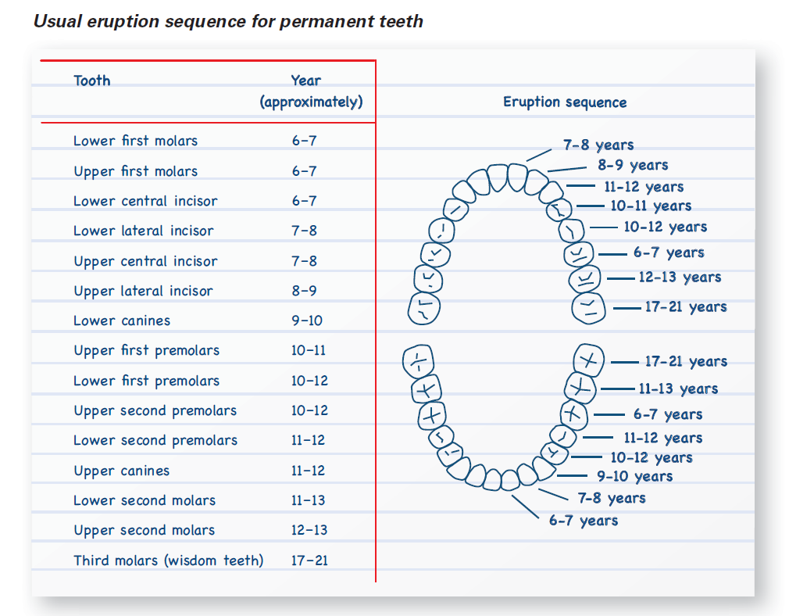

Appendix B

Drink well

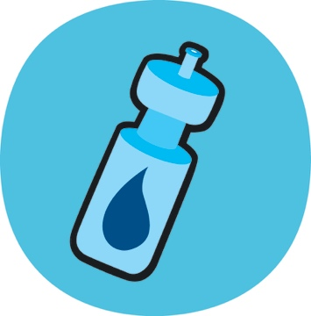 | 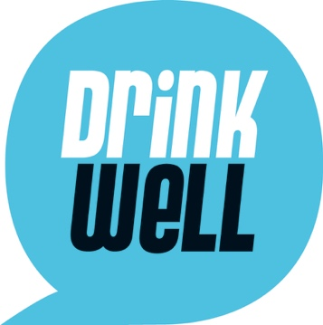 | 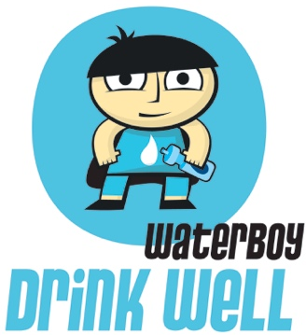
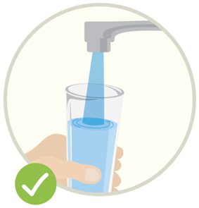 | 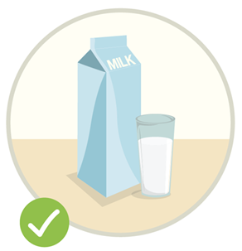 | 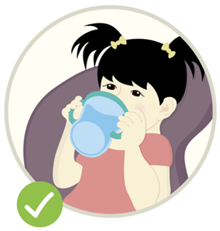
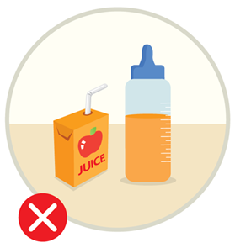 | 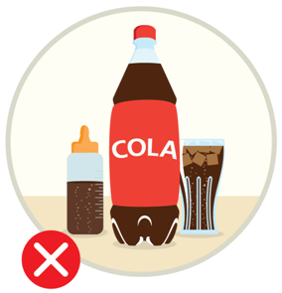 | 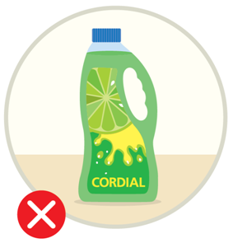
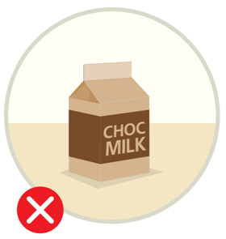

Appendix C

Eat well

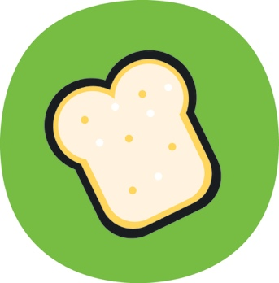 | 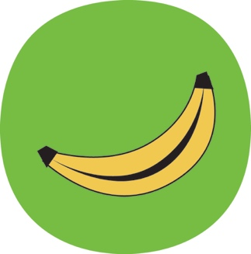 | 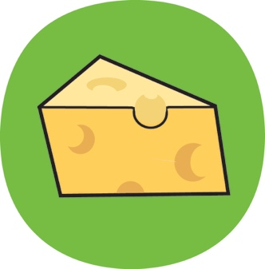
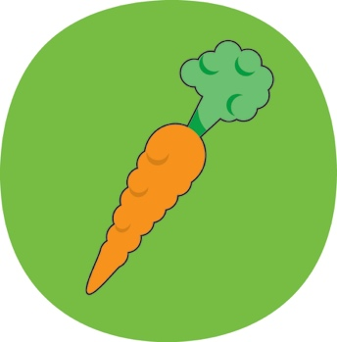 | 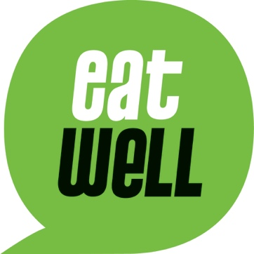 | 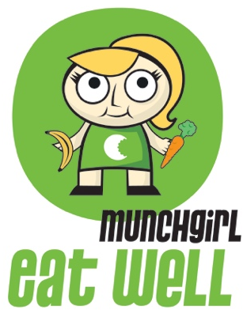
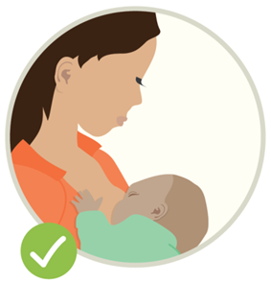 | 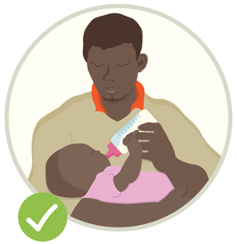 | 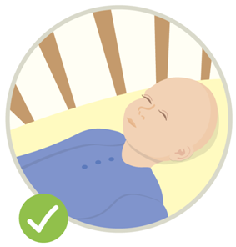
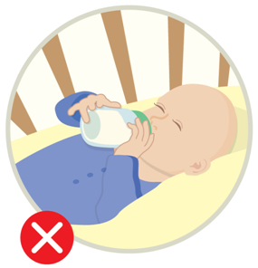 | 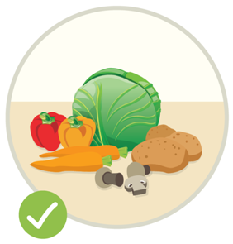 | 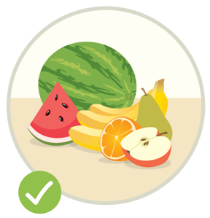
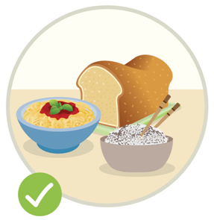 | 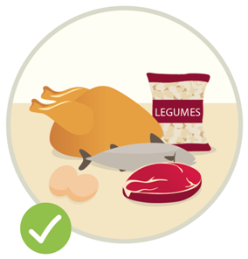 | 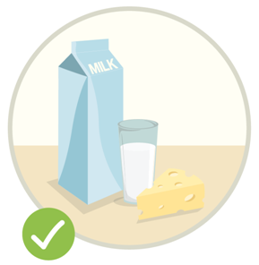
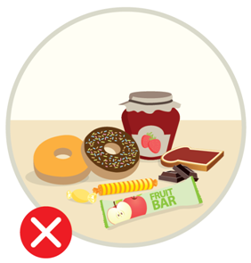

Appendix D

Clean well

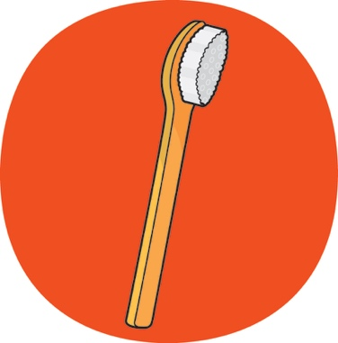 | 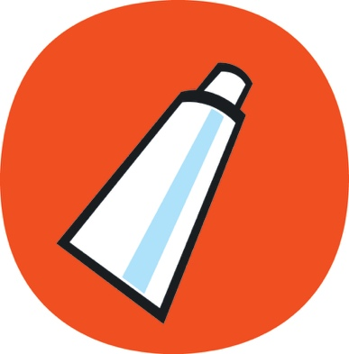 | 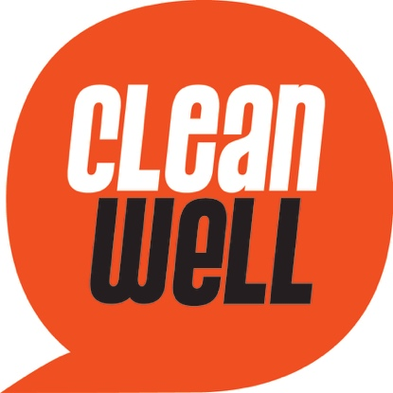
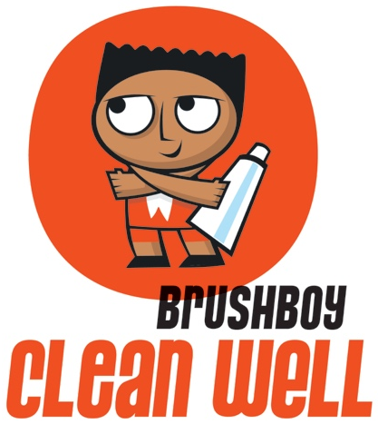 | 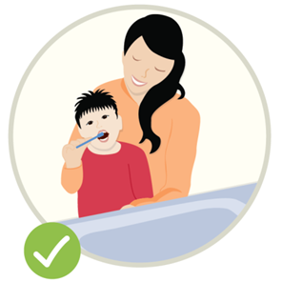 | 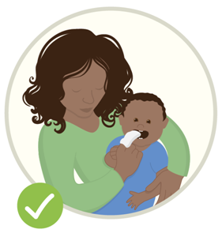
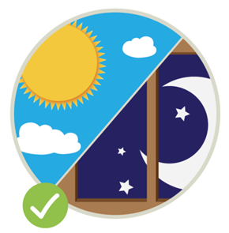 | 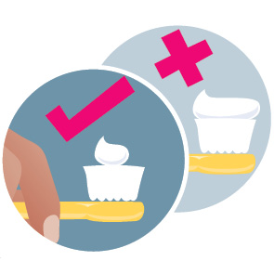 | 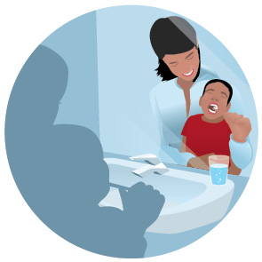
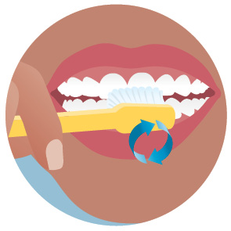 | 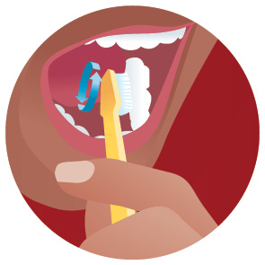 | 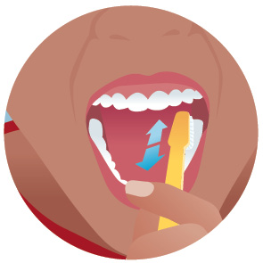
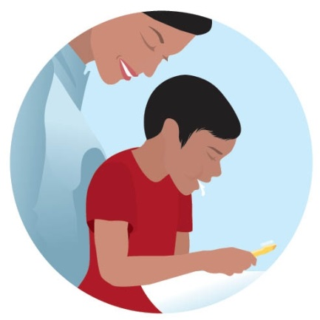

Appendix E

Stay well

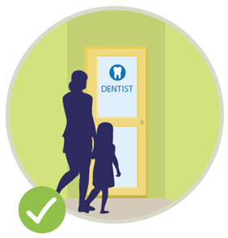 | 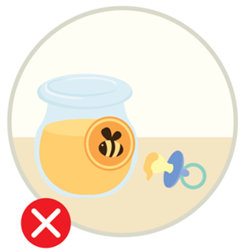 | 